**Figures**



**Figure 1: Data structure.** We are using a data set composed of 155 samples. For 152 of them we have whole-transcriptome RNA-Seq reads and for 105 of them we have mass-spec proteomics reads, 103 of 155 samples have corresponding mRNA and protein reads. Data covers four different carbon sources: glucose, glycerol, gluconate, and lactate; and variation for two different ions: high sodium and both low and high magnesium. Collected samples span a two-week interval, which can be divided into 3 growth phases exponential stationary and late stationary.

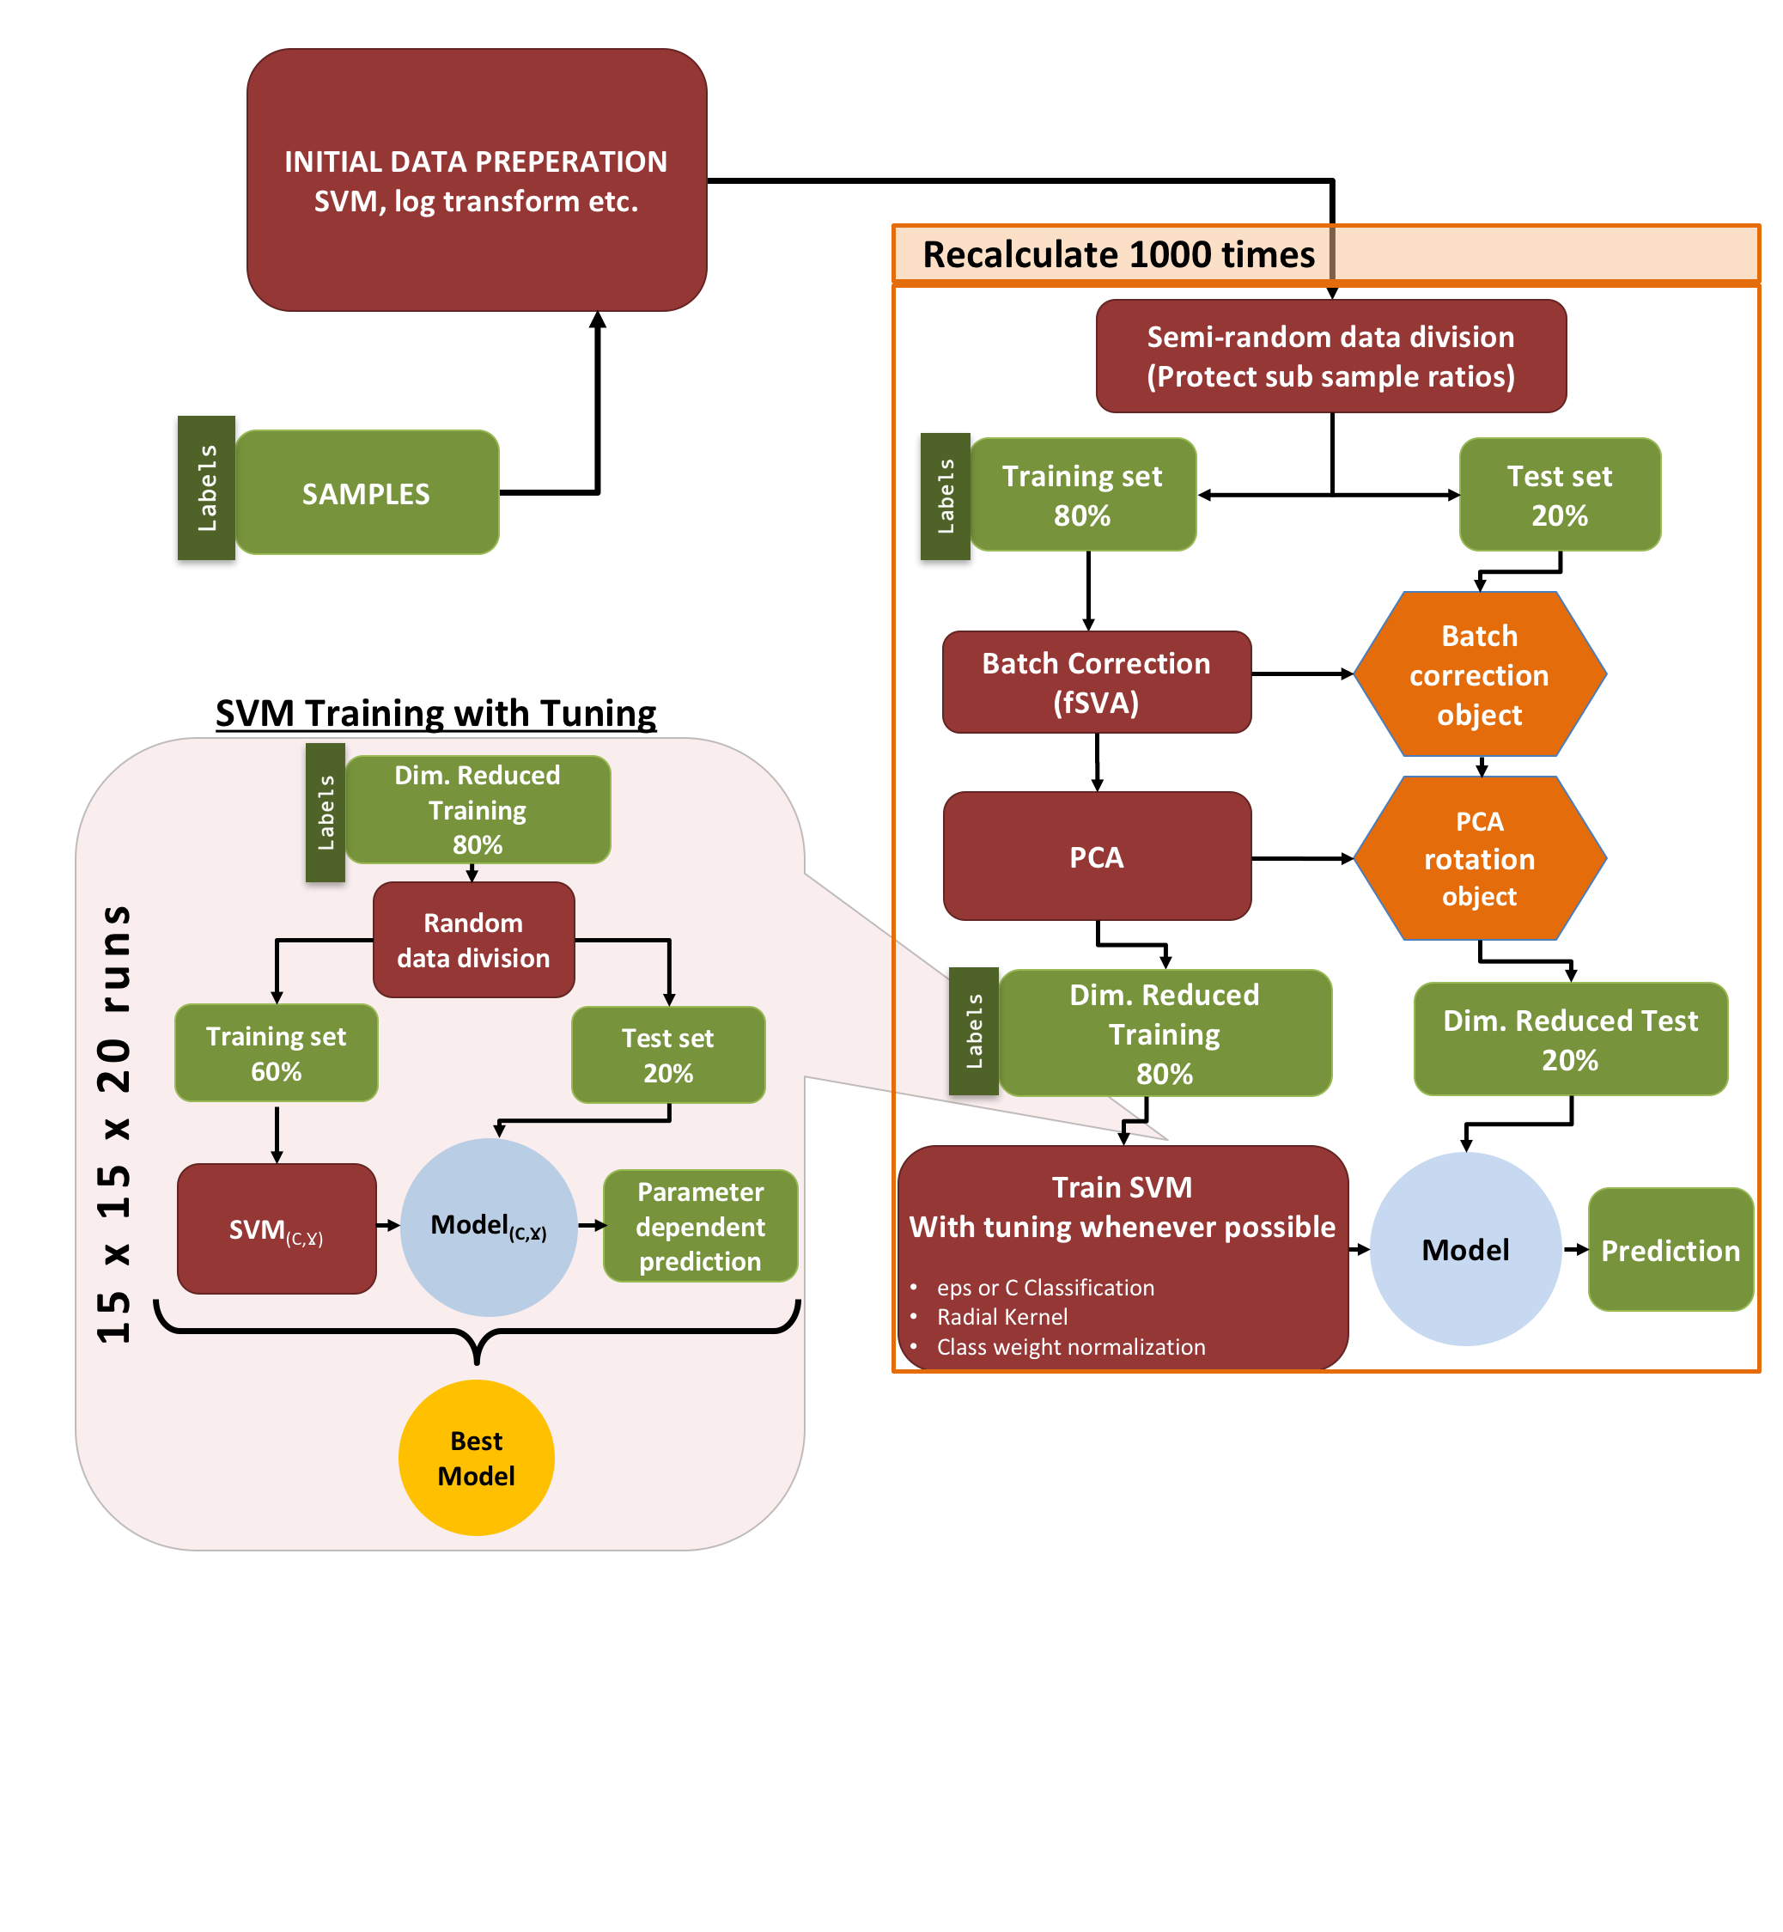

**Figure 2: Machine learning pipeline.** The machine learning pipeline can be separated into three parts. Initial process test loop and tune loop. After initial preparation data is separated into 2 parts as training and test, after applying fSVA and PCA to training data we obtain we apply a C-Classification SVM with radial kernel with given class weights which are used to get rid of the penalty on categories with few samples. For the regression analyze we use eps regression SVM with tuning for parameters “*c*” and “*gamma*”, where c is the cost variable and gamma is the parameter associated with radial kernel. After obtaining the model from SVM we apply the model on test data which was batch corrected and rotated with batch correction object and PCA rotation object.



**Figure 3 (all data mRNA).** The prediction results for the pipeline for mRNA data. For each figure rows represent the true values and columns represent the predicted values. For each condition we run the pipeline for 1000 times. (A) Prediction results for 3 growth phases (B) Prediction results for 4 different carbon sources. (C) Prediction results for 3 different Mg levels. (D) Prediction results for 2 different sodium levels.



**Figure 4 (All data protein)** The prediction results for the pipeline for protein data. For each figure rows represent the true values and columns represent the predicted values. For each condition we run the pipeline for 1000 times. (A) Prediction results for 3 growth phases (B) Prediction results for 4 different carbon sources. (C) Prediction results for 3 different Mg levels. (D) Prediction results for 2 different sodium levels.



**Figure 5. Overall prediction trends in time.** Summary results for 3 different conditions carbon source, Mg levels, Na levels for 2 different growth phases exponential and stationary. The success variable in y axis is defined in between random and perfect prediction. Random prediction line represents expected value of a truly random classifier on specific data. Perfect line represents the result if every sample in the test set predicted correctly for all runs. The trends between exponential and stationary phase represents the decrease in predictability



**Figure 8. Complex predictions based on mRNA data**



F**igure 6 Complex predictions based on protein data**



**Figure 7. Complex predictions based on combined mRNA and protein data.**



Figure 9 (Regression growth time)



Figure 10 (Regression Mg)



Figure 11 (Regression Na)